Recurrsion

//1To check wheter a program is reccrusive or not

#include<iostream>

#include<cmath>

using namespace std;

int fun(int);

int main()

{

int p,take;

cout<<"Enter the number:";

cin>>p;

take=fun(p);

if(p==take)

cout<<take<<" is Armstrong ";

else

cout<<take<<"is not Armstrong ";

}

int fun(int x1)

{

int n=x1,s=0,r;

if(n>0)

{

return (pow(n%10,3)) + fun(n/10);

}

/* CHECKING IF THE NUMBER ENTERED AND THE REVERSE NUMBER IS EQUAL OR NOT */

}

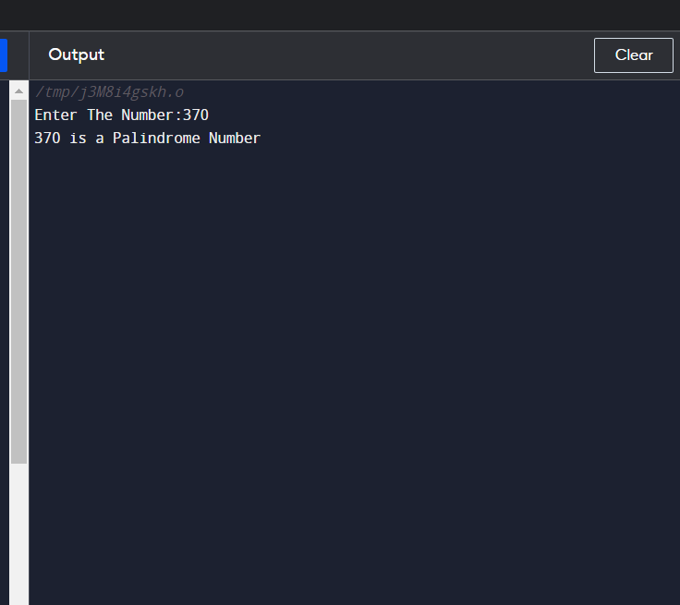

//2 count digits of number

#include<iostream>

using namespace std;

int count_digit(int num)

{

static int count=0;

if(num!=0)

{

count++;

count_digit(num/10);

}

return count;

}

int main()

{

int n;

cout<<"Enter a number:";

cin>>n;

cout<<"The number of digits in the Given Number is "<<count_digit(n);

}

//3 Sum of digits of a number

#include<iostream>

using namespace std;

int count_digit(int num)

{

static int s=0;

if(num!=0)

{

s=s+num%10;

count_digit(num/10);

}

return s;

}

int main()

{

int n;

cout<<"Enter a number:";

cin>>n;

cout<<"The sum of digits in the Given Number is "<<count_digit(n);

}

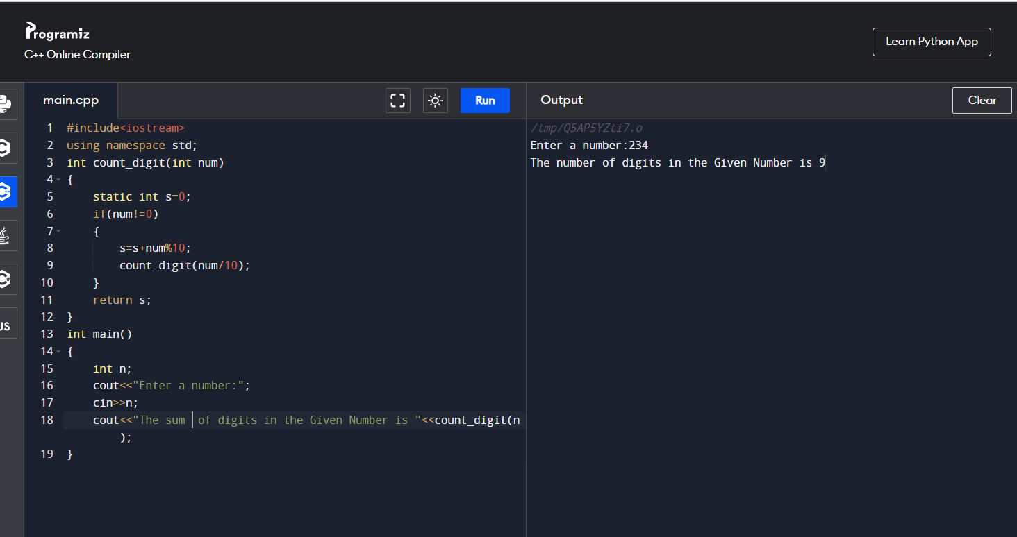

//4 no is even or not

#include <iostream>

using namespace std;

//function prototype/declaration

int isEven(int);

int main()

{

int n;

cout<<"Enter a number: ";

cin>>n;

if(isEven(n))

cout<<"It is an EVEN Number";

else

cout<<"Is is an ODD Number";

cout<<endl;

return 0;

}

//function definition/body

int isEven(int n)

{

if(n == 0)

return 1;

else if(n == 1)

return 0;

else if(n<0)

return isEven(-n);

else

return isEven(n-2);

}

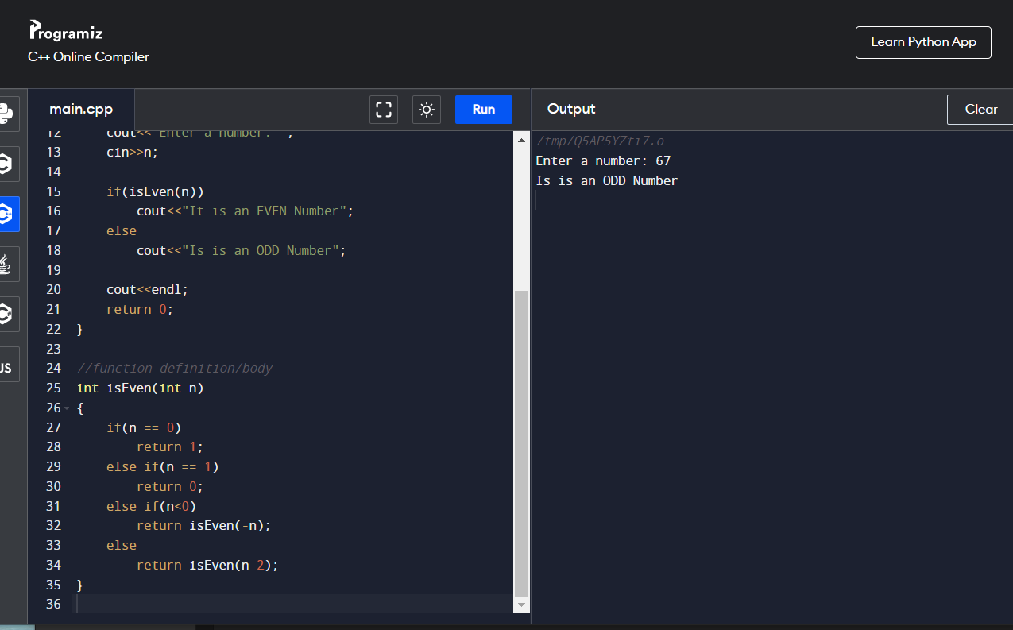

5 factorial of a program using recursion

#include<iostream>

using namespace std;

int main()

{

int factorial(int);

int fact,value;

cout<<"Enter any number: ";

cin>>value;

fact=factorial(value);

cout<<"Factorial of a number is: "<<fact<<endl;

return 0;

}

int factorial(int n)

{

if(n<0)

return(-1); /*Wrong value*/

if(n==0)

return(1); /*Terminating condition*/

else

{

return(n*factorial(n-1));

}

} 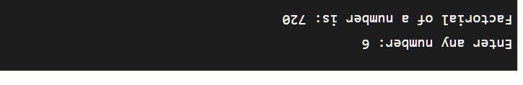

//6 #include <iostream>

using namespace std;

int main()

{

int n, num, digit, rev = 0;

cout << "Enter a positive number: ";

cin >> num;

n = num;

do

{

digit = num % 10;

rev = (rev * 10) + digit;

num = num / 10;

} while (num != 0);

cout << " The reverse of the number is: " << rev << endl;

if (n == rev)

cout << " The number is a palindrome.";

else

cout << " The number is not a palindrome.";

return 0;

}

7 reverse of number

#include <stdio.h>

void reverse(int number)

{

if (number < 10)

{

printf("%d",number);

return;

}

else

{

printf("%d",number % 10);

reverse(number/10);

}

}

int main()

{

int num;

printf("Enteryour number:");

scanf("%d",&num);

printf("Reverse of the input number is:\n ");

reverse(num);

}

7 sum of digits of recursion

// Recursive C++ program to find sum of digits

// of a number

#include <bits/stdc++.h>

using namespace std;

// Function to check sum of digit using recursion

int sum_of_digit(int n)

{

if (n == 0)

return 0;

return (n % 10 + sum_of_digit(n / 10));

}

// Driven code

int main()

{

int num = 12345;

int result = sum_of_digit(num);

cout << "Sum of digits in "<< num

<<" is "<<result << endl;

return 0;

}